# NITTE MEENAKSHI INSTITUTE OF TECHNOLOGY

(AN AUTONOMOUS INSTITUTION, AFFILIATED TO VISVESVARAYA TECHNOLOGICAL UNIVERSITY, BELGAUM, APPROVED BY AICTE & GOVT.OF KARNATAKA



# MINI PROJECT REPORT

on

## Snap Grocery System

*Submitted in partial fulfilment of the requirement for the award of Degree of*

*Bachelor of Engineering*

*in*

*Information Science and Engineering*

*Submitted by:*

##### Kanta Aishwarya 1NT20IS072

Under the Guidance of

Mr. Hanumanthappa

Assistant Professors, Dept. of ISE, NMIT



Department of Information Science and Engineering

**(Accredited by NBA Tier-1)**

2023-2024

(AN AUTONOMOUS INSTITUTION, AFFILIATED TO VISVESVARAYA TECHNOLOGICAL UNIVERSITY, BELGAUM

Department of Information Science and Engineering

**(Accredited by NBA Tier-1)**



##### CERTIFICATE

This is to certify that the Project Report on “**Snap Grocery System”** is an authentic work carried out by **Kanta Aishwarya (1NT20IS072)** Bonafede students of Nitte Meenakshi Institute of Technology, Bangalore in partial fulfilment for the award of the degree of Bachelor of Engineering in Information Science and Engineering of Visvesvaraya Technological University, Belagavi during the academic year 2023-2024***.*** It is certified that all corrections and suggestions indicated during the internal assessment has beenincorporated in the report.

**Faculty**

Mr. Hanumanthappa Assistant Professor, Dept. ISE,

NMIT Bangalore

## Abstract

This project details the development of a sophisticated grocery shopping application designed for the Android platform. Leveraging the capabilities of Android Studio, the application aims to enhance the user experience by providing a seamless and efficient means of managing grocery lists, exploring products, and making purchases. The backbone of the application relies on the robust SQLite database for secure and efficient data storage.

The grocery app offers a user-friendly interface, allowing customers to effortlessly browse through a diverse range of products, add items to their virtual shopping carts, and proceed with secure transactions. The utilization of Android Studio ensures optimal performance, responsiveness, and compatibility across a wide range of Android devices.

The SQLite database plays a pivotal role in storing and managing crucial data, including user profiles, product details, and transaction records. This relational database system facilitates quick and reliable data retrieval, contributing to the overall efficiency and responsiveness of the application.

Key features of the grocery app include personalized user profiles, real-time inventory updates, and a secure checkout process. The application not only simplifies the shopping experience for users but also provides valuable insights for inventory management and business analytics.

Through the integration of Android Studio and SQLite, this grocery app project showcases the potential for creating a scalable and user-centric mobile solution for the modern retail landscape. The combination of a powerful development environment and a reliable database system ensures the application's robustness, making it a viable solution for users seeking a convenient and efficient way to manage their grocery shopping experience.

## Acknowledgement

The satisfaction and euphoria that accompany the successful completion of any task would be incomplete without the mention of the people who made it possible, whose constant guidance and encouragement crowned our effort with success. I express my sincere gratitude to our Principal **Dr. H. C. Nagaraj**, Nitte Meenakshi Institute of Technology for providing facilities.

We wish to thank our HoD**, Dr. Mohan S. G.** for the excellent environment created to further educational growth in our college. We also thank him for the invaluable guidance provided which has helped in the creation of a better project.

I hereby like to thank ***Mr. Hanumanthappa, Assistant Professor*** Department of Information Science & Engineering on their periodic inspection, time to time evaluation of the project and help to bring the project to the present form.

Thanks to our Departmental Project coordinators. We also thank all our friends, teaching and non-teaching staff at NMIT, Bangalore, for all the direct and indirect help provided in the completion of the project.



## Table of Contents

**Abstract Acknowledgement**

|  |  |  |
| --- | --- | --- |
| **Sl.no** | **Chapter Title** | **Page Number** |
| 1 | Introduction | 1-2 |
| 2 | Objectives | 3 |
| 3 | Problem Statement | 4 |
| 4 | System Design | 5 |
| 5 | Implementation | 6-7 |
| 6 | Results and Important Code Snippets | 8-13 |
| 7 | Conclusion | 14 |



**List of Figures**

1. Welcome page 10
2. Login page 11
3. View page 12
4. Description page 13



**Chapter-1**

### INTRODUCTION

In an era characterized by the proliferation of mobile technologies, the demand for innovative solutions that streamline everyday tasks has never been more pronounced. This project encapsulates the development of a cutting-edge grocery shopping application tailored for the Android platform. Focused on delivering a seamless and user-friendly experience, this application harnesses the capabilities of Android Studio, the premier integrated development environment for Android applications. Complemented by the robust SQLite database, the application not only enhances user interactions but also ensures secure and efficient data management.

The contemporary consumer landscape is marked by a desire for convenience, efficiency, and personalized experiences. Recognizing this paradigm shift, our grocery app emerges as a comprehensive solution that redefines the traditional grocery shopping experience. Through the intuitive interface of Android Studio, users gain access to a myriad of features designed to simplify and enhance their shopping journey.

At the heart of this development is the incorporation of SQLite, a versatile and efficient relational database management system. This choice ensures a structured and secure storage mechanism for vital information, including user profiles, product details, and transaction records. The synergy between Android Studio and SQLite not only guarantees a responsive and dynamic application but also facilitates the seamless integration of features crucial to modern retail environments.

As we delve into the details of this grocery app project, it becomes apparent that the amalgamation of advanced development tools and a robust database system sets the stage for a transformative and scalable solution. This introduction serves as an invitation to explore the intricacies of an application poised to revolutionize the grocery shopping landscape, offering users a technologically advanced, yet accessible, means of managing their everyday needs.

**1.1Technologies used:**

Technologies involved in building a Snap Grocery system:

#### Frontend:

**Technology: Android Studio** ( The official integrated development environment (IDE) for Android app development.)

##### Components:

* + **Operating System Compatibility**: Microsoft Windows 7/8/10 (32 or 64 bit), Mac OS X 10.8.5,Unity desktop on Ubuntu or GNU/Linux Debian.
  + **Recommended RAM**: 4GB RAM.
  + **Android Development Requirements**: 1GB for Android SDK, Android 2.2 Toolkit.
  + **Java Development:** Java Development Kit (JDK) 7.
  + **Integrated Development Environment (IDE):** Android Studio.

#### Backend:

##### Backend Requirements:

* + **Coding Languages:** Java 1.6, PHP**. Technology Stack:**
  + **Operating System for Mobile:** Android.
  + **Hardware Specifications**: Pentium IV 2.4 GHz Processor, 40 GB Hard Disk, 512 Mb RAM, 15 VGA Colour Monitor, Logitech Mouse.

**Chapter-2**

### OBJECTIVES

The objectives for our grocery shopping application project are aimed at creating a user-centric, efficient, and secure mobile experience. Firstly, the app will boast a user-friendly interface, ensuring that customers can effortlessly navigate, search for products, and complete transactions with ease. For Flutter development, a key objective involves achieving cross-platform compatibility, ensuring a consistent and seamless experience for users on both Android and iOS devices. Real-time inventory updates will be implemented to provide users with accurate product information and prevent order discrepancies. Security is a top priority, with the implementation of a robust user authentication system to protect user data and manage authorized access. We aim to streamline the order processing and checkout process, minimizing user effort and enhancing the overall shopping experience. Integration with secure payment gateways is pivotal for facilitating smooth and secure transactions within the app. Personalization features, such as user profiles, purchase history, and recommendations, will be incorporated to enrich the customer experience and foster user loyalty. Additional objectives include providing offline capabilities, leveraging location-based services, conducting comprehensive testing, designing for scalability, ensuring accessibility and inclusivity, implementing a feedback mechanism, and adhering to data security and privacy regulations. Marketing and promotional features will also be integrated to run campaigns, offer discounts, and effectively engage users. These objectives, guided by the principles of clarity, measurability, achievability, relevance, and timeliness, collectively aim to deliver a robust and user-focused grocery shopping application.

**Chapter-3**

### PROBLEM STATEMENT

Our project involves developing a sophisticated grocery shopping application with a focus on improving the overall user experience. We aim to create a seamless, secure, and user-friendly mobile solution that addresses existing inefficiencies in grocery shopping experiences including incorporating cross-platform compatibility, real-time inventory updates, and robust security features to provide a comprehensive and transformative solution for modern consumers.

**Chapter-4**

### SYSTEM DESIGN

##### System Architecture:

1. **Frontend (Mobile App):**
   * User Interface (UI): Develop the app interface using HTML, CSS, and JavaScript within the Android Studio environment for optimal user experience (UX).
   * Authentication: Implement Firebase Authentication for secure user login and registration.

##### Backend:

* + Server-Side Scripting: Employ PHP to handle server-side scripting for data processing, interaction with the database, and managing server requests.
  + API Endpoints: Develop RESTful APIs for communication between the mobile app and server, facilitating data exchange.

##### Database:

**Local Database (SQLite):**

Stores user profiles, product details, and other essential data on the mobile device. Supports offline functionality and provides quick access to frequently used data. **Server Database:**

Centralized storage for data managed by the backend services.

##### Integration and Communication:

* + Firebase Services: Integrate Firebase services such as Firestore for real-time data synchronization and Cloud Functions for server-side logic.
  + Cloud Storage: Utilize Cloud Storage for storing user avatars and multimedia files**.**

##### Security Measures:

* + Implement HTTPS for secure data transmission between the app and the server.
  + Apply input validation and encryption techniques to protect sensitive data.

##### Scalability Considerations:

* + Design the database architecture for scalability using normalized tables and efficient indexing.
  + Leverage Firebase services that can automatically scale based on demand.

**Chapter-5**

### IMPLEMENTATION

#### Technology Stack:

* **Frontend Development:** HTML, CSS, JavaScript for building the user interface in the Android application.
* **Backend Development:** Firebase for server-side scripting, SQLite for database management, facilitating data storage and retrieval.

##### Implementation Phases: Core Functionality:

1. **Planning Phase:** Define project objectives, requirements, and functionalities. Create a project timeline and resource allocation plan.
2. **Development Phase:** Implement backend functionality using firebase and SQLite for data management. Develop the Android app using Java/Kotlin.
3. **Integration & Testing:** Integrate frontend, backend, and mobile components. Perform unit testing, functional testing, and user acceptance testing.
4. **Deployment:** Publish the Android app on Google Play Store. Deploy the server-side components to a hosting platform.
5. **Maintenance & Updates:** Regularly update the app, fix bugs, and enhance functionalities based on user feedback.

##### Security and Scalability:

* + **Security Measures:** Implement Firebase Authentication for secure user login. Employ HTTPS for data transmission, input validation to prevent SQLite injection, and encryptiontechniques for sensitive data.
  + **Scalability Considerations:** Design a scalable database structure, utilize cloud-based services like Firestore, which can scale based on demand. Optimize code for performance to handle increased user loads efficiently.

##### Implementation Tools and Resources:

* + **IDEs**: Android Studio for Android app development,firebase.
  + **Database Management:** Utilizing SQLite for local mobile device storage and employing MySQL Workbench for comprehensive database design and management on the server-side**.**
  + **Cloud Services:** Firebase for authentication, database, and cloud functions.
  + **Testing Tools**: Android Emulator for app testing, Postman for API testing.

**Chapter-6.**

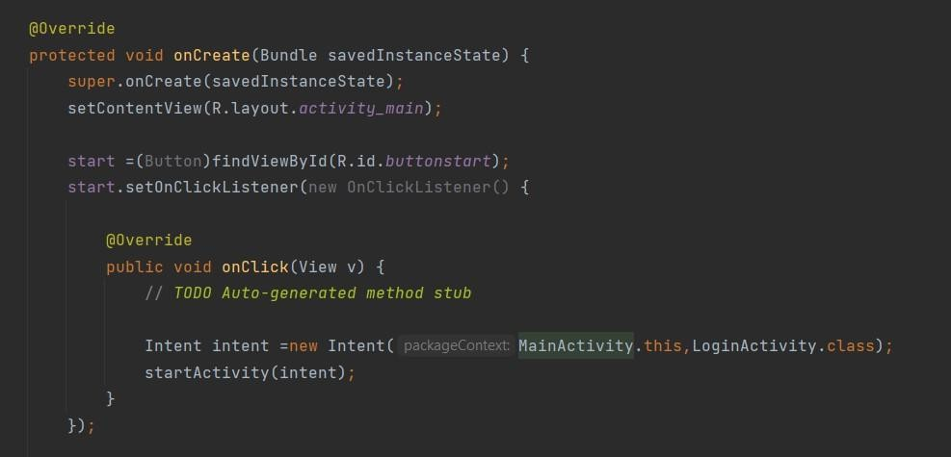**Important Code Snippets**

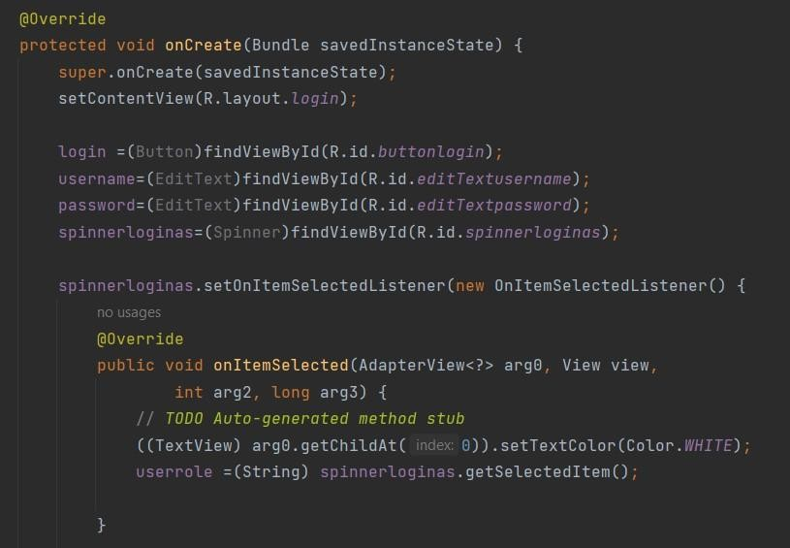**Fig 6.1 MainActivity**

**Fig 6.2:Oncreate**

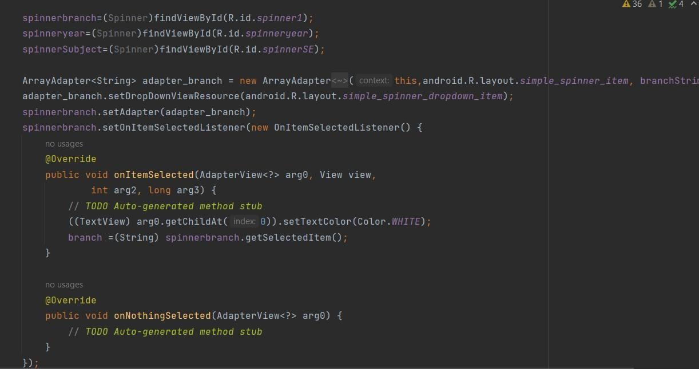

**Fig 6.3 Item selected**

### RESULTS AND SNAPSHOTS

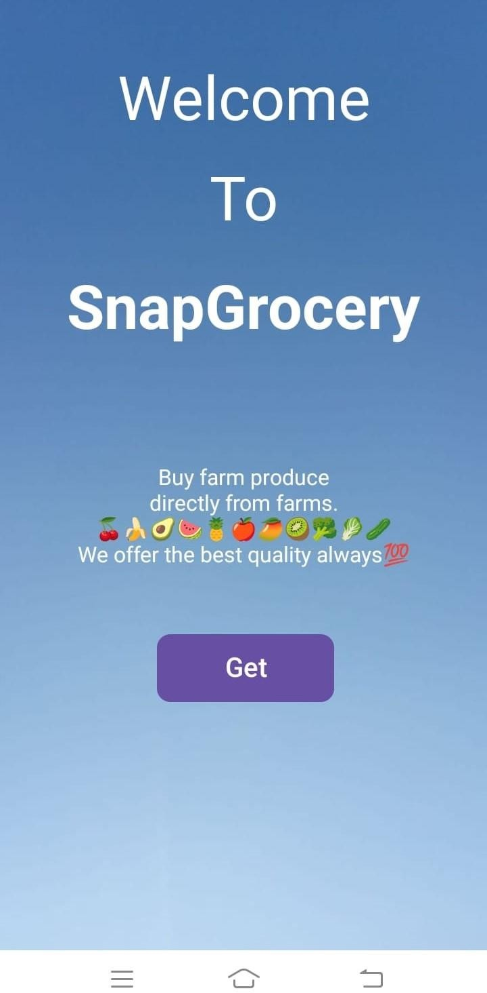

**Fig 1:Welcome page**

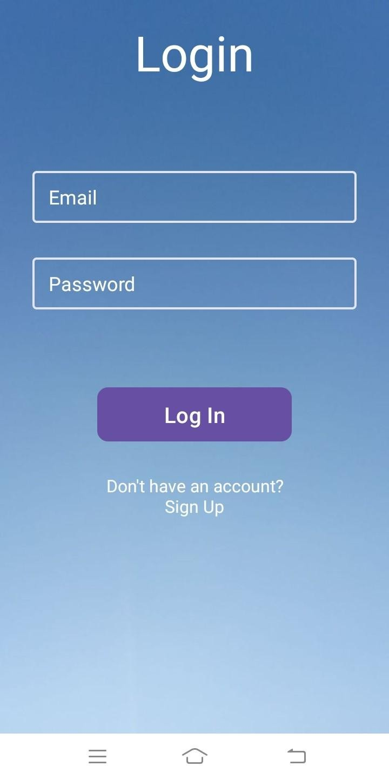

**Fig 2: Login Page**

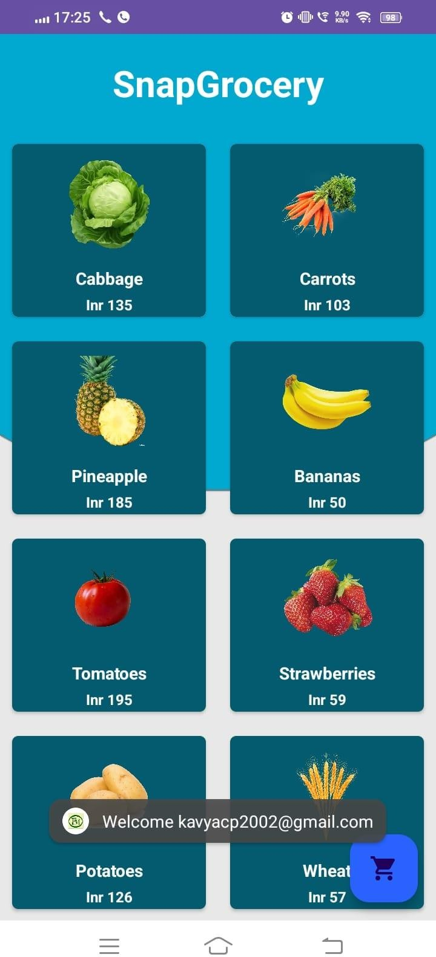

**Fig 3: View page**

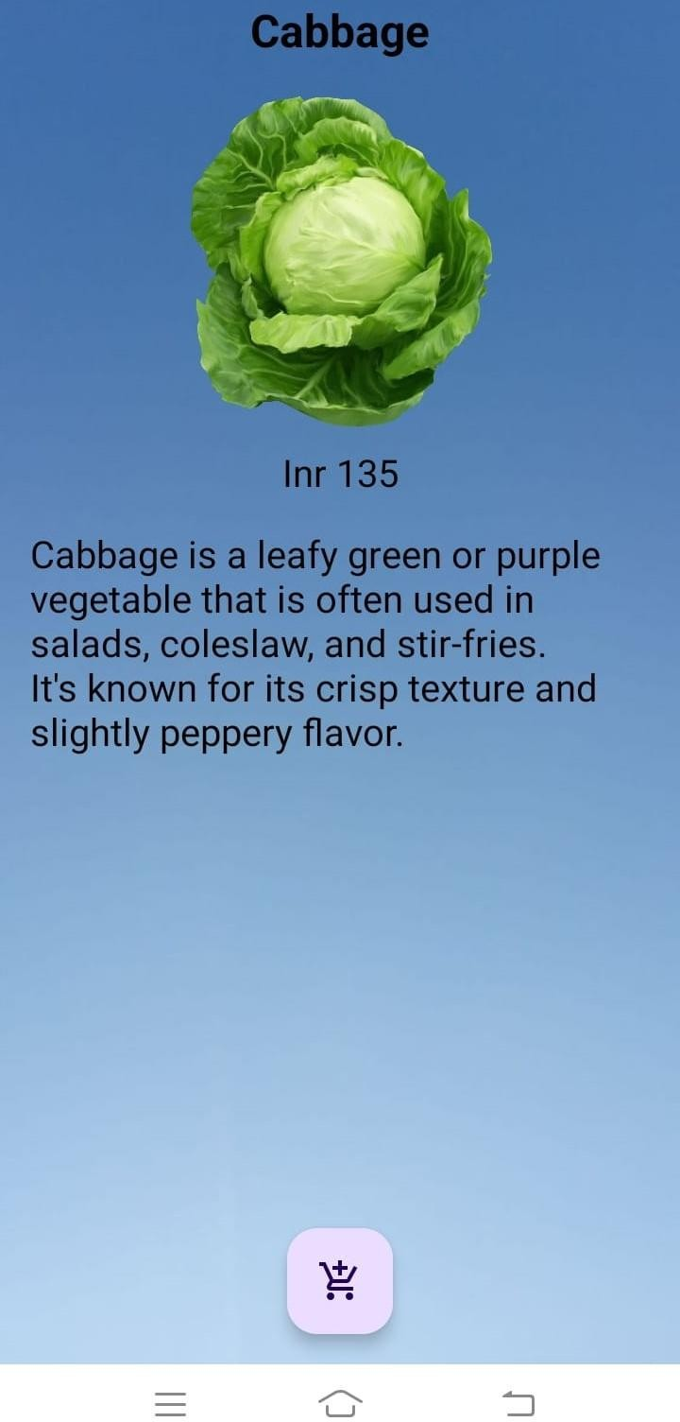

**Fig 4 : Description page**

**Chapter-7**

### CONCLUSION

In summary, the grocery shopping application stands as a testament to technological innovation in retail. Its user-friendly interface, cross-platform compatibility, and integration with efficient backend systems contribute to a seamless shopping experience. The app not only simplifies the consumer journey but also streamlines operations for vendors. With real-time insights and robust database management, the application offers a modern solution for grocery retail. As we conclude, the positive impact on user convenience and operational efficiency positions this app as

a valuable asset in the digital retail landscape.

**Chapter-8**

# REFERENCES

1. Somasundaram, V., Kannan. M, Sriram, V., 2016, “Mobile based Grocery Management System”, Indian Journal of Science and Technology.
2. Rakhi Joshi, Shete, V., Somani, S. B., 2015, “Android Based Ecommerce system”, International Journal of Advanced Research in Computerand Communication Engineering.